FREQUENCIES VARIABLES=NOMOS
/BARCHART FREQ
/ORDER=ANALYSIS.

Frequencies

[DataSet1] C:\BACKUP\APPLIED STATISTICS\DATA_SET_1.sav

Statistics
NOMOS
N | Valid | 50
N | Missing | 0

NOMOS
 |  | Frequency | Percent | Valid Percent | Cumulative Percent
Valid | ΔΡΑΜΑ | 10 | 20,0 | 20,0 | 20,0
Valid | ΚΑΒΑΛΑ | 7 | 14,0 | 14,0 | 34,0
Valid | ΚΙΛΚΙΣ | 9 | 18,0 | 18,0 | 52,0
Valid | ΚΟΖΑΝΗ | 13 | 26,0 | 26,0 | 78,0
Valid | ΠΕΛΛΑ | 11 | 22,0 | 22,0 | 100,0
Valid | Total | 50 | 100,0 | 100,0

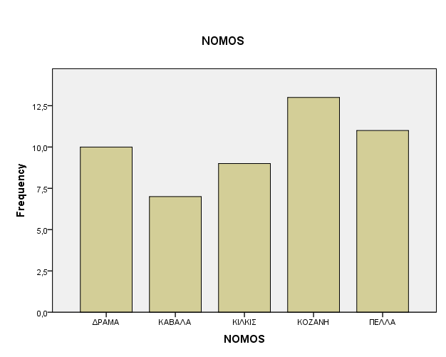

FREQUENCIES VARIABLES=NOMOS
/PIECHART FREQ
/FORMAT=AFREQ
/ORDER=ANALYSIS.

Frequencies

[DataSet0] C:\BACKUP\APPLIED STATISTICS\DATA_SET_1.sav

Statistics
NOMOS
N | Valid | 50
N | Missing | 0

NOMOS
 |  | Frequency | Percent | Valid Percent | Cumulative Percent
Valid | ΚΑΒΑΛΑ | 7 | 14,0 | 14,0 | 14,0
Valid | ΚΙΛΚΙΣ | 9 | 18,0 | 18,0 | 32,0
Valid | ΔΡΑΜΑ | 10 | 20,0 | 20,0 | 52,0
Valid | ΠΕΛΛΑ | 11 | 22,0 | 22,0 | 74,0
Valid | ΚΟΖΑΝΗ | 13 | 26,0 | 26,0 | 100,0
Valid | Total | 50 | 100,0 | 100,0

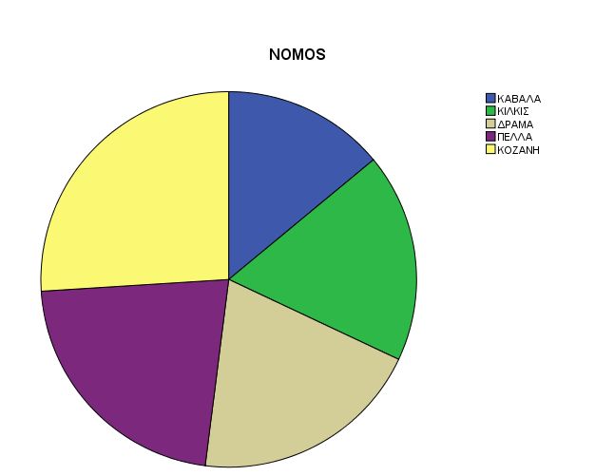

DESCRIPTIVES VARIABLES=IPSOS BAROS HLIKIA
/SAVE
/STATISTICS=MEAN STDDEV VARIANCE RANGE MIN MAX SEMEAN KURTOSIS SKEWNESS.

Descriptives

[DataSet0] C:\BACKUP\APPLIED STATISTICS\DATA_SET_1.sav

Descriptive Statistics
 | N | Range | Minimum | Maximum | Mean |  | Std. Deviation | Variance | Skewness |  | Kurtosis
 | Statistic | Statistic | Statistic | Statistic | Statistic | Std. Error | Statistic | Statistic | Statistic | Std. Error | Statistic | Std. Error
IPSOS | 50 | 25 | 135 | 160 | 145,68 | 1,004 | 7,098 | 50,385 | ,422 | ,337 | -,841 | ,662
BAROS | 50 | 31,00 | 27,00 | 58,00 | 42,5800 | 1,23490 | 8,73204 | 76,249 | ,145 | ,337 | -1,117 | ,662
HLIKIA | 50 | 540,00 | 3328,00 | 3868,00 | 3559,0200 | 18,92633 | 133,82939 | 17910,306 | ,231 | ,337 | -,770 | ,662
Valid N (listwise) | 50

FREQUENCIES VARIABLES=IPSOS
/NTILES=4
/PERCENTILES=10.0 90.0
/STATISTICS=STDDEV VARIANCE RANGE MINIMUM MAXIMUM SEMEAN MEAN SKEWNESS SESKEW KURTOSIS SEKURT
/HISTOGRAM NORMAL
/ORDER=ANALYSIS.

Frequencies

[DataSet0] C:\BACKUP\APPLIED STATISTICS\DATA_SET_1.sav

Statistics
IPSOS
N | Valid | 50,000
N | Missing | ,000
Mean |  | 145,680
Std. Error of Mean |  | 1,004
Std. Deviation |  | 7,098
Variance |  | 50,385
Skewness |  | ,422
Std. Error of Skewness |  | ,337
Kurtosis |  | -,841
Std. Error of Kurtosis |  | ,662
Range |  | 25,000
Minimum |  | 135,000
Maximum |  | 160,000
Percentiles | 10 | 138,000
Percentiles | 25 | 139,750
Percentiles | 50 | 144,500
Percentiles | 75 | 152,000
Percentiles | 90 | 155,900

IPSOS
 |  | Frequency | Percent | Valid Percent | Cumulative Percent
Valid | 135 | 3 | 6,0 | 6,0 | 6,0
Valid | 136 | 1 | 2,0 | 2,0 | 8,0
Valid | 138 | 5 | 10,0 | 10,0 | 18,0
Valid | 139 | 3 | 6,0 | 6,0 | 24,0
Valid | 140 | 1 | 2,0 | 2,0 | 26,0
Valid | 141 | 2 | 4,0 | 4,0 | 30,0
Valid | 142 | 6 | 12,0 | 12,0 | 42,0
Valid | 143 | 2 | 4,0 | 4,0 | 46,0
Valid | 144 | 2 | 4,0 | 4,0 | 50,0
Valid | 145 | 4 | 8,0 | 8,0 | 58,0
Valid | 146 | 2 | 4,0 | 4,0 | 62,0
Valid | 147 | 1 | 2,0 | 2,0 | 64,0
Valid | 148 | 1 | 2,0 | 2,0 | 66,0
Valid | 149 | 1 | 2,0 | 2,0 | 68,0
Valid | 150 | 1 | 2,0 | 2,0 | 70,0
Valid | 151 | 2 | 4,0 | 4,0 | 74,0
Valid | 152 | 3 | 6,0 | 6,0 | 80,0
Valid | 153 | 1 | 2,0 | 2,0 | 82,0
Valid | 154 | 2 | 4,0 | 4,0 | 86,0
Valid | 155 | 2 | 4,0 | 4,0 | 90,0
Valid | 156 | 1 | 2,0 | 2,0 | 92,0
Valid | 158 | 1 | 2,0 | 2,0 | 94,0
Valid | 159 | 1 | 2,0 | 2,0 | 96,0
Valid | 160 | 2 | 4,0 | 4,0 | 100,0
Valid | Total | 50 | 100,0 | 100,0

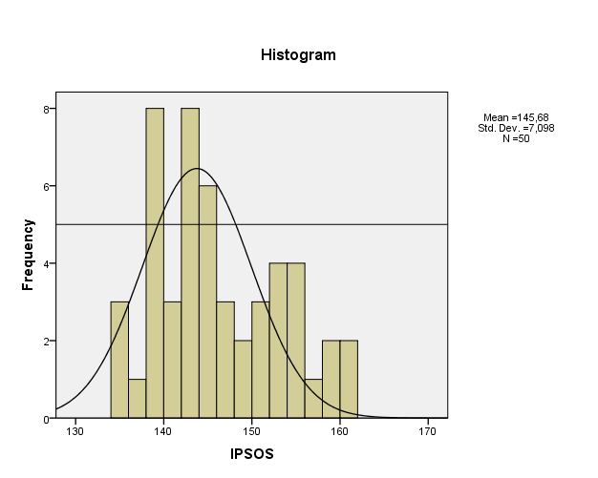

FREQUENCIES VARIABLES=IPSOS_CD
/HISTOGRAM NORMAL
/FORMAT=AFREQ
/ORDER=ANALYSIS.

Frequencies

Notes
Output Created |  | 2009-09-23T17:55:53.900
Comments
Input | Data | C:\BACKUP\APPLIED STATISTICS\DATA_SET_1.sav
Input | Active Dataset | DataSet0
Input | Filter | <none>
Input | Weight | <none>
Input | Split File | <none>
Input | N of Rows in Working Data File | 50
Missing Value Handling | Definition of Missing | User-defined missing values are treated as missing.
Missing Value Handling | Cases Used | Statistics are based on all cases with valid data.
Syntax |  | FREQUENCIES VARIABLES=IPSOS_CD  /HISTOGRAM NORMAL  /FORMAT=AFREQ  /ORDER=ANALYSIS.
Resources | Processor Time | 0:00:00.281
Resources | Elapsed Time | 0:00:00.250

[DataSet0] C:\BACKUP\APPLIED STATISTICS\DATA_SET_1.sav

Warnings
A sort keyword (DVALUE, AFREQ or DFREQ) has been used in conjunction with subcommands HISTOGRAM, NTILES or PERCENTILES. The sort keyword will be ignored.

Statistics
IPSOS_CD
N | Valid | 50
N | Missing | 0

IPSOS_CD
 |  | Frequency | Percent | Valid Percent | Cumulative Percent
Valid | 1,00 | 13 | 26,0 | 26,0 | 26,0
Valid | 2,00 | 16 | 32,0 | 32,0 | 58,0
Valid | 3,00 | 6 | 12,0 | 12,0 | 70,0
Valid | 4,00 | 10 | 20,0 | 20,0 | 90,0
Valid | 5,00 | 5 | 10,0 | 10,0 | 100,0
Valid | Total | 50 | 100,0 | 100,0

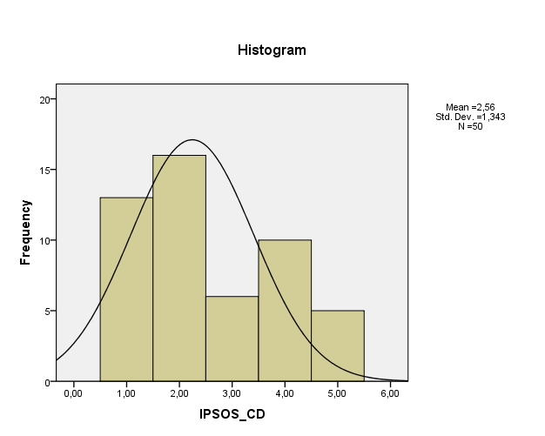

FREQUENCIES VARIABLES=IPSOS_CD
/HISTOGRAM NORMAL
/FORMAT=AFREQ
/ORDER=ANALYSIS.

Frequencies
[DataSet0] C:\BACKUP\APPLIED STATISTICS\DATA_SET_1.sav

Statistics
IPSOS_CD
N | Valid | 50
N | Missing | 0

IPSOS_CD
 |  | Frequency | Percent | Valid Percent | Cumulative Percent
Valid | 1,00 | 13 | 26,0 | 26,0 | 26,0
Valid | 2,00 | 16 | 32,0 | 32,0 | 58,0
Valid | 3,00 | 6 | 12,0 | 12,0 | 70,0
Valid | 4,00 | 10 | 20,0 | 20,0 | 90,0
Valid | 5,00 | 5 | 10,0 | 10,0 | 100,0
Valid | Total | 50 | 100,0 | 100,0

Descriptive Statistics
 | N | Range | Minimum | Maximum | Mean |  | Std. Deviation | Variance | Skewness |  | Kurtosis
 | Statistic | Statistic | Statistic | Statistic | Statistic | Std. Error | Statistic | Statistic | Statistic | Std. Error | Statistic | Std. Error
IPSOS | 50 | 25 | 135 | 160 | 145,68 | 1,004 | 7,098 | 50,385 | ,422 | ,337 | -,841 | ,662
BAROS | 50 | 31 | 27 | 58 | 42,58 | 1,235 | 8,732 | 76,249 | ,145 | ,337 | -1,117 | ,662
HLIKIA | 50 | 540,00 | 3328,00 | 3868,00 | 3559,0200 | 18,92633 | 133,82939 | 17910,306 | ,231 | ,337 | -,770 | ,662
Valid N (listwise) | 50

FREQUENCIES VARIABLES=IPSOS
/FORMAT=NOTABLE
/NTILES=4
/PERCENTILES=10.0 90.0
/STATISTICS=STDDEV VARIANCE RANGE MINIMUM MAXIMUM SEMEAN MEAN MEDIAN SKEWNESS SESKEW KURTOSIS SEKURT
/HISTOGRAM NORMAL
/ORDER=ANALYSIS.

Frequencies

[DataSet1] C:\BACKUP\APPLIED STATISTICS\DATA_SET_1.sav

Statistics
IPSOS
N | Valid | 50,000
N | Missing | ,000
Mean |  | 145,680
Std. Error of Mean |  | 1,004
Median |  | 144,500
Std. Deviation |  | 7,098
Variance |  | 50,385
Skewness |  | ,422
Std. Error of Skewness |  | ,337
Kurtosis |  | -,841
Std. Error of Kurtosis |  | ,662
Range |  | 25,000
Minimum |  | 135,000
Maximum |  | 160,000
Percentiles | 10 | 138,000
Percentiles | 25 | 139,750
Percentiles | 50 | 144,500
Percentiles | 75 | 152,000
Percentiles | 90 | 155,900

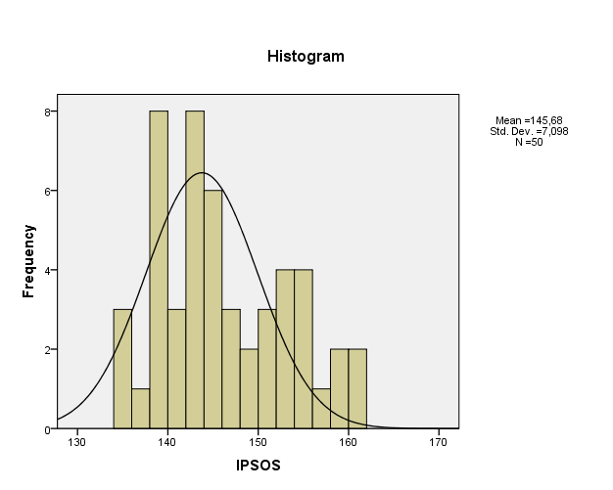

FREQUENCIES VARIABLES=IPSOS_R
/NTILES=4
/PERCENTILES=10.0 90.0
/STATISTICS=STDDEV VARIANCE RANGE MINIMUM MAXIMUM SEMEAN MEAN SKEWNESS SESKEW KURTOSIS SEKURT
/HISTOGRAM NORMAL
/FORMAT=AFREQ
/ORDER=ANALYSIS.

Frequencies

[DataSet1] C:\BACKUP\APPLIED STATISTICS\DATA_SET_1.sav

Statistics
IPSOS_R
N | Valid | 50,000
N | Missing | ,000
Mean |  | 2,560
Std. Error of Mean |  | ,190
Std. Deviation |  | 1,343
Variance |  | 1,802
Skewness |  | ,447
Std. Error of Skewness |  | ,337
Kurtosis |  | -1,070
Std. Error of Kurtosis |  | ,662
Range |  | 4,000
Minimum |  | 1,000
Maximum |  | 5,000
Percentiles | 10 | 1,000
Percentiles | 25 | 1,000
Percentiles | 50 | 2,000
Percentiles | 75 | 4,000
Percentiles | 90 | 4,900

IPSOS_R
 |  | Frequency | Percent | Valid Percent | Cumulative Percent
Valid | 1 | 13 | 26,0 | 26,0 | 26,0
Valid | 2 | 16 | 32,0 | 32,0 | 58,0
Valid | 3 | 6 | 12,0 | 12,0 | 70,0
Valid | 4 | 10 | 20,0 | 20,0 | 90,0
Valid | 5 | 5 | 10,0 | 10,0 | 100,0
Valid | Total | 50 | 100,0 | 100,0

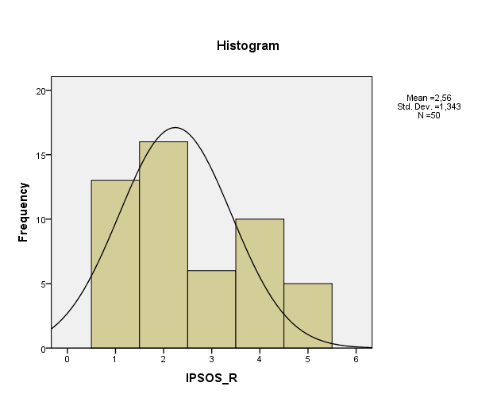

RECODE IPSOS (135 thru 140=137.5) (140 thru 145=142.5) (145 thru 150=147.5) (150 thru 155=152.5) (155 thru 160=157.5) INTO IPSOS_RV.
EXECUTE.
GRAPH
/LINE(SIMPLE)=COUNT BY IPSOS_RV.

Graph

[DataSet1] C:\BACKUP\APPLIED STATISTICS\DATA_SET_1.sav

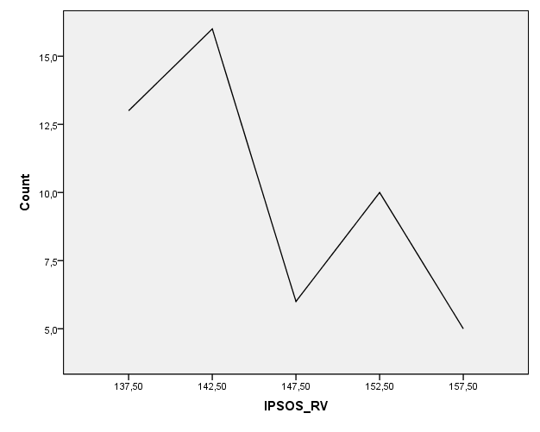

EXAMINE VARIABLES=XRONOS
/PLOT BOXPLOT STEMLEAF HISTOGRAM NPPLOT
/COMPARE GROUP
/MESTIMATORS HUBER(1.339) ANDREW(1.34) HAMPEL(1.7,3.4,8.5) TUKEY(4.685)
/PERCENTILES(5,10,25,50,75,90,95) HAVERAGE
/STATISTICS DESCRIPTIVES EXTREME
/CINTERVAL 95
/MISSING LISTWISE
/NOTOTAL.

Explore

[DataSet1] C:\BACKUP\APPLIED STATISTICS\DATA_SET_1.sav

Case Processing Summary
 | Cases
 | Valid |  | Missing |  | Total
 | N | Percent | N | Percent | N | Percent
XRONOS | 50 | 100,0% | 0 | ,0% | 50 | 100,0%

Descriptives
 |  |  | Statistic | Std. Error
XRONOS | Mean |  | 361,8400 | 3,42194
XRONOS | 95% Confidence Interval for Mean | Lower Bound | 354,9634
XRONOS | 95% Confidence Interval for Mean | Upper Bound | 368,7166
XRONOS | 5% Trimmed Mean |  | 362,0333
XRONOS | Median |  | 361,5000
XRONOS | Variance |  | 585,484
XRONOS | Std. Deviation |  | 24,19678
XRONOS | Minimum |  | 307,00
XRONOS | Maximum |  | 410,00
XRONOS | Range |  | 103,00
XRONOS | Interquartile Range |  | 33,00
XRONOS | Skewness |  | -,131 | ,337
XRONOS | Kurtosis |  | -,425 | ,662

M-Estimators
 | Huber's M-Estimatorª | Tukey's Biweight^{b} | Hampel's M-Estimator^{c} | Andrews' Wave^{d}
XRONOS | 362,1779 | 362,2040 | 362,0911 | 362,2041
a. The weighting constant is 1,339.
b. The weighting constant is 4,685.
c. The weighting constants are 1,700, 3,400, and 8,500
d. The weighting constant is 1,340*pi.

Percentiles
 |  | Percentiles
 |  | 5 | 10 | 25 | 50 | 75 | 90 | 95
Weighted Average(Definition 1) | XRONOS | 318,2000 | 325,3000 | 345,0000 | 361,5000 | 378,0000 | 395,9000 | 404,3500
Tukey's Hinges | XRONOS |  |  | 345,0000 | 361,5000 | 378,0000

Extreme Values
 |  |  | Case Number | Value
XRONOS | Highest | 1 | 18 | 410,00
XRONOS | Highest | 2 | 38 | 406,00
XRONOS | Highest | 3 | 19 | 403,00
XRONOS | Highest | 4 | 44 | 398,00
XRONOS | Highest | 5 | 11 | 396,00
XRONOS | Lowest | 1 | 1 | 307,00
XRONOS | Lowest | 2 | 3 | 316,00
XRONOS | Lowest | 3 | 2 | 320,00
XRONOS | Lowest | 4 | 39 | 325,00
XRONOS | Lowest | 5 | 4 | 325,00

Tests of Normality
 | Kolmogorov-Smirnovª |  |  | Shapiro-Wilk
 | Statistic | df | Sig. | Statistic | df | Sig.
XRONOS | ,092 | 50 | ,200* | ,985 | 50 | ,783
a. Lilliefors Significance Correction
*. This is a lower bound of the true significance.

XRONOS

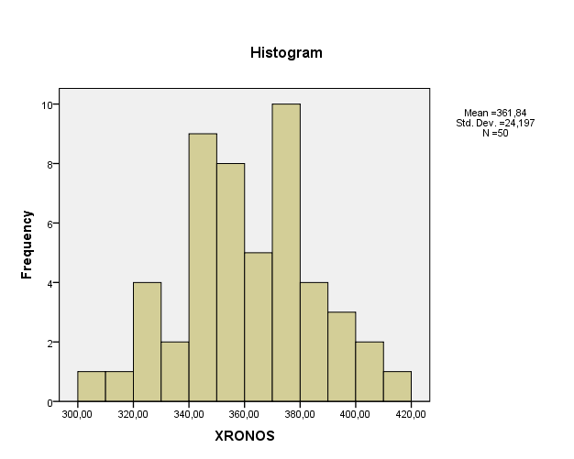

XRONOS Stem-and-Leaf Plot

Frequency Stem & Leaf

1,00 30 . 7
1,00 31 . 6
4,00 32 . 0558
2,00 33 . 29
9,00 34 . 225556888
8,00 35 . 44556799
5,00 36 . 46788
10,00 37 . 4456688889
4,00 38 . 2256
3,00 39 . 568
2,00 40 . 36
1,00 41 . 0

Stem width: 10,00
Each leaf: 1 case(s)

